1. Statistical analyses

In order to test our hypotheses, we used data collected in the original study and conducted appropriate statistical analyses using the Rstudio statistical software. In addition to conducting statistical tests, we also graphed these tests to get a visual representation of the data. In reporting our data, we think it important to point out that of the original sample size (*N* = 3134), 737 subjects’ data were excluded because the participants did not complete the survey or left answers to our questions of interest blank, leaving an analytic sample of *N* = 2397. We excluded these participants for simplicity’s sake with the acknowledgement that doing so will make our findings less valid. For hypothesis 1, subjects’ data were excluded if they noted that they did not have a disability but later listed a specific disability (*N* = 412), leaving an analytic sample size of *N* = 1985. For hypothesis 2, subjects’ data that were included in hypothesis 1 were excluded if they did not have a disability (*N* = 1254), leaving an analytic sample size of *N* = 731. Hypothesis 3 used the original analytic sample (*N* = 2397). However, the sample size for each analysis was still very large, which allowed for respectable power and reasonable conclusions to be drawn from these reported findings.

 In testing our first hypothesis that there is a difference between mean stress of individuals reporting a disability and those reporting having no disability, we conducted an independent samples *t*-test for comparing the means of two groups. The mean stress level of the disability group (*M* = 33.98) and the average stress level of the group that did not report a disability (*M* = 32.35) differed slightly but significantly, *t*(54) = 3.36, *p* < .001. This finding supports our hypothesis that there is a significant difference in stress level between the group with a disability and the group without a disability.

**Figure 1**

*t-test Between Presence of Disability and Stress Level*

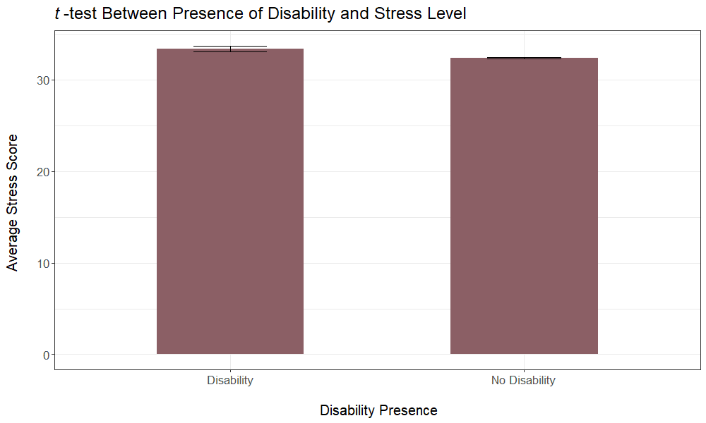

*Note.* Error bars represent standard errors.

To test if the type of disability affected the level of stress reported (hypothesis 2), we conducted an ANOVA analyzing the specific type of disability as the independent variable and the average level of stress reported as the dependent variable. The main effect of disability type for stress level was not significant, *F*(5, 725) = 0.79, *p* = .556. This finding does not support our hypothesis. There does not seem to be a difference in stress levels between groups with different disabilities. This finding could be due to the fact that many people reported having disabilities of more than one type.

**Figure 2**

*ANOVA Between Types of Disability and Stress Level*

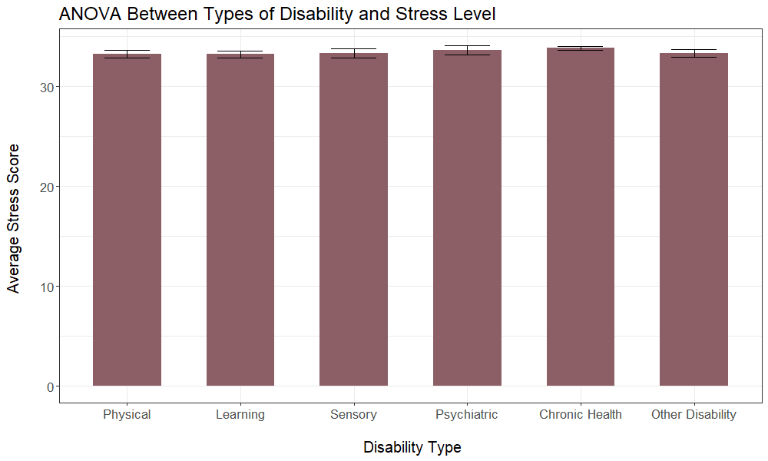

*Note*. Error bars represent standard errors.

Finally, to test our third hypothesis that there would be a relationship between the average distress caused by physical health symptoms (e.g., headache, dizziness) and stress level, we conducted a Pearson’s correlation. We found the correlation to be moderately weak, *r* = 0.30, *p* <0.001, suggesting that there is a significant, positive relationship between physical symptoms and stress level, but not a strong one.

**Figure 3**

*Pearson Correlation Between Average Stress Level and Physical Symptoms*

*Distress*

